**WEEK 6_REACT HANDSON**

**Exercise 1: Create a new React Application**

**Scenario:**

Create a new React Application with the name “myfirstreact”, Run the application to print “welcome to the first session of React” as heading of that page.

**CODE:**

**Account:**

**App.js :**function App() {

return (

<div className="App">

<h1>welcome to the first session of React</h1>

</div>

);

}

export default App;

**OUTPUT:**

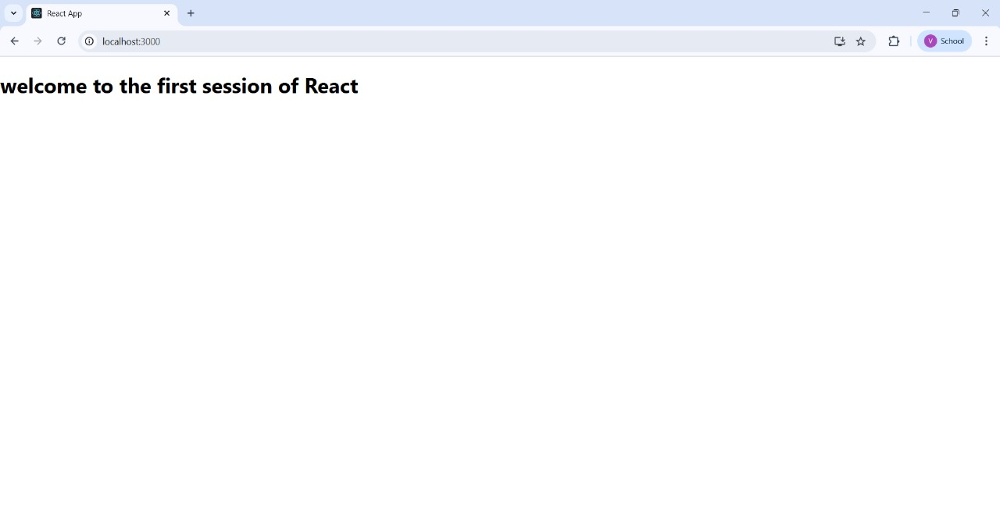

**Exercise 2: Create a react app for Student Management Portal**

**SCENARIO:**

Create a react app for Student Management Portal named StudentApp and create a component named Home which will display the Message “Welcome to the Home page of Student Management Portal”. Create another component named About and display the Message “Welcome to the About page of the Student Management Portal”. Create a third component named Contact and display the Message “Welcome to the Contact page of the Student Management Portal”. Call all the three components.

**CODE:**

**Home.js :**

import React from 'react';

function Home() {

return (

<div>

<h1>Welcome to the Home page of Student Management Portal</h1>

</div>

);

}

export default Home;

**About.js:**

import React from 'react';

function About() {

return (

<div>

<h1>Welcome to the About page of the Student Management Portal</h1>

</div>

);

}

export default About;

**Contact.js:**

import React from 'react';

function Contact() {

return (

<div>

<h1>Welcome to the Contact page of the Student Management Portal</h1>

</div>

);

}

export default Contact;

**App.js:**

import React from 'react';

import Home from './Components/Home';

import About from './Components/About';

import Contact from './Components/Contact';

function App() {

return (

<div className="App">

<Home />

<About />

<Contact />

</div>

);

}

export default App;

OUTPUT: 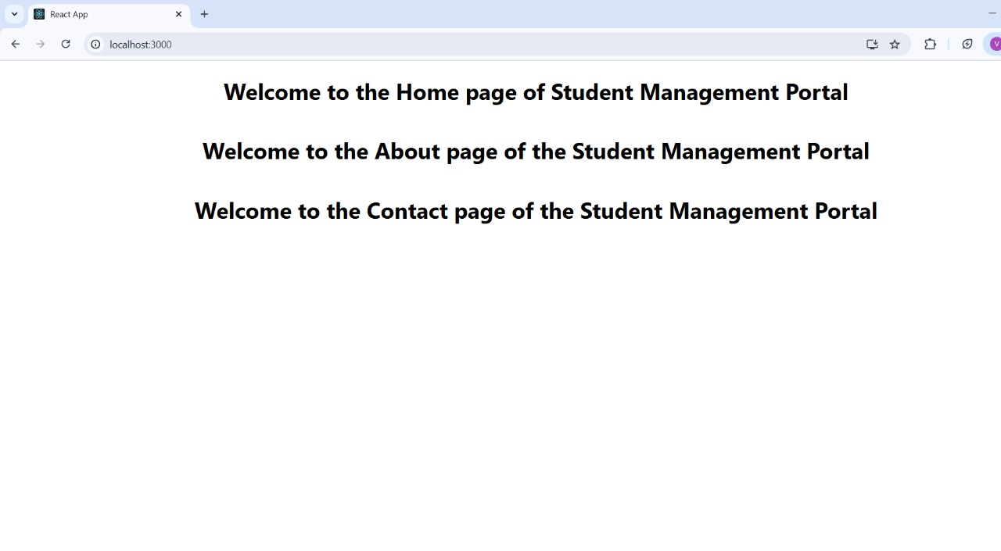

**Exercise 3: Create a react app for Student Management Portal named scorecalculatorapp**

**SCENARIO:**

Create a react app for Student Management Portal named scorecalculatorapp and create a function component named “CalculateScore” which will accept Name, School, Total and goal in order to calculate the average score of a student and display the same.

**CODE:**

**CalculateScore.js:**

import React from 'react';

import '../Stylesheets/mystyle.css';

function CalculateScore(props) {

const average = props.total / 5;

return (

<div className="score-container">

<h2>Student Score Details</h2>

<p><strong>Name:</strong> {props.name}</p>

<p><strong>School:</strong> {props.school}</p>

<p><strong>Total Marks:</strong> {props.total}</p>

<p><strong>Goal:</strong> {props.goal}</p>

<p><strong>Average Score:</strong> {average}</p>

</div>

);}

export default CalculateScore;

**mystyle.css:**

.score-container {

background-color: #f0f8ff;

padding: 20px;

margin: 30px auto;

border-radius: 10px;

width: 60%;

text-align: center;

box-shadow: 0 0 10px rgba(0,0,0,0.1);

}

.score-container h2 {

color: #2e8b57;

}

App.js:

import React from 'react';

import './App.css';

import CalculateScore from './Components/CalculateScore';

function App() {

return (

<div className="App">

<CalculateScore

name="Arjun"

school="Green Valley High School"

total={450}

goal="Become a Software Engineer"

/>

</div>

);

}

export default App;

**OUTPUT:**

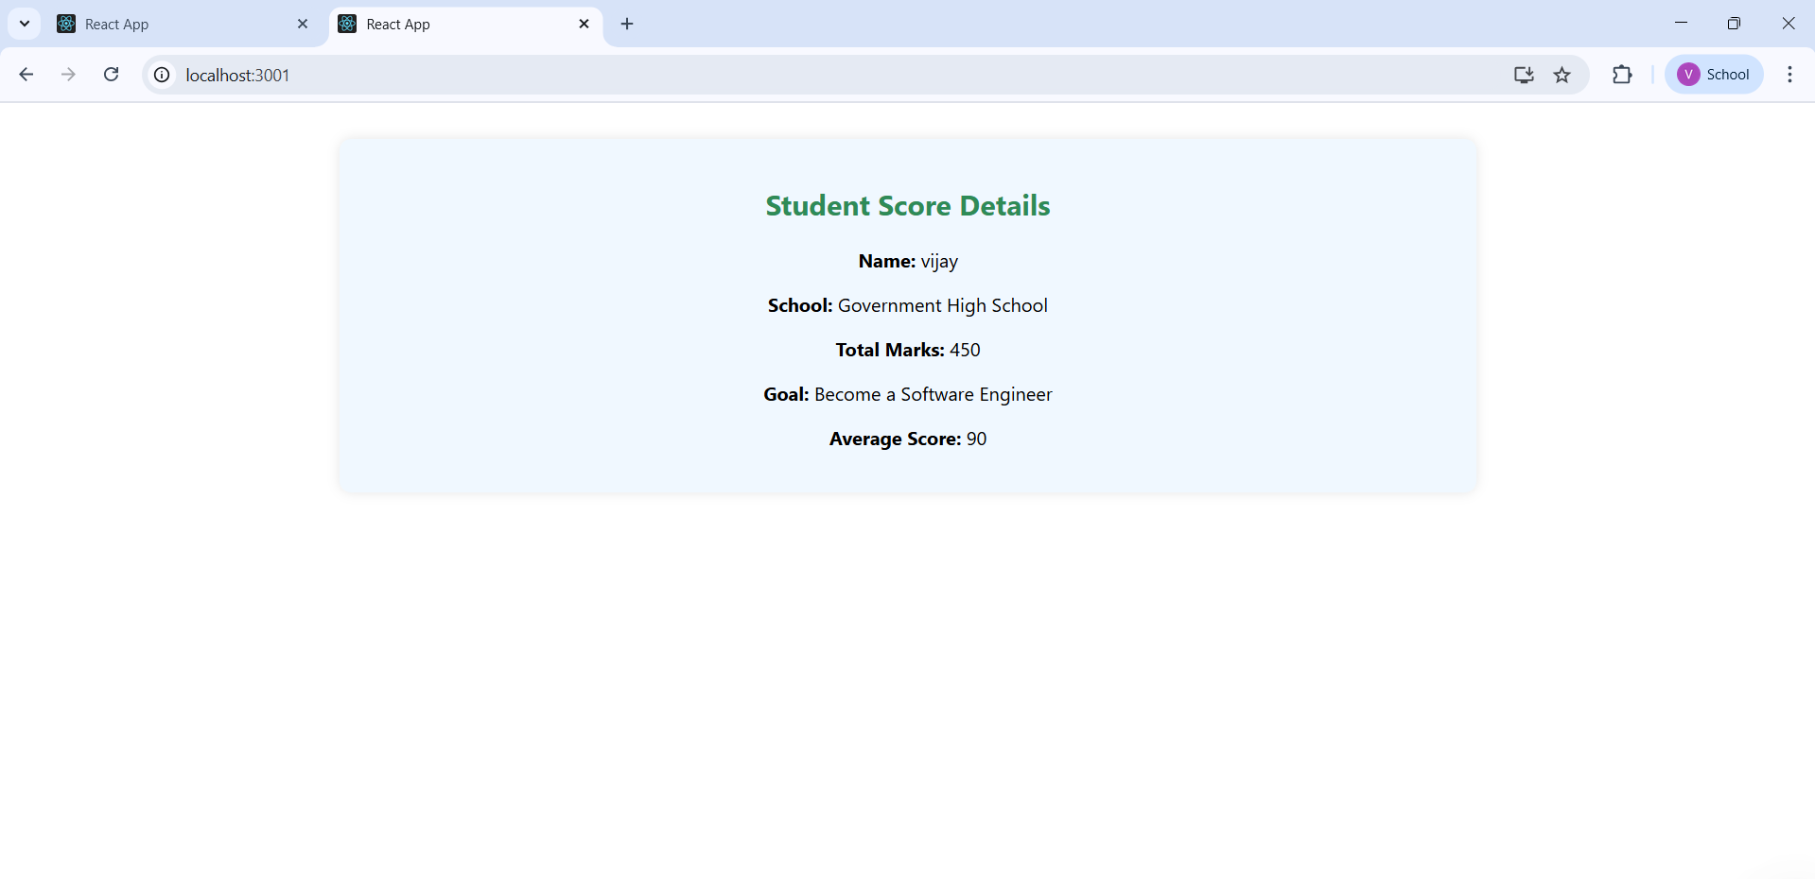

**Exercise 4: Create a new react application with the name as “blogapp”**

**SCENARIO:**

Create a new react application using create-react-app tool with the name as “blogapp”

**CODE:**

**Post.js:**

class Post {

constructor(userId, id, title, body) {

this.userId = userId;

this.id = id;

this.title = title;

this.body = body;

}

}

export default Post;

**posts.js:**

import React, { Component } from 'react';

import Post from './Post';

class Posts extends Component {

constructor(props) {

super(props);

this.state = {

posts: [],

hasError: false

};

}

loadPosts = async () => {

try {

const response = await fetch('https://jsonplaceholder.typicode.com/posts');

const data = await response.json();

const postObjects = data.map(post => new Post(post.userId, post.id, post.title, post.body));

this.setState({ posts: postObjects });

} catch (error) {

this.setState({ hasError: true });

}

}

componentDidMount() {

this.loadPosts();

}

componentDidCatch(error, info) {

alert("An error occurred: " + error.message);

this.setState({ hasError: true });

}

render() {

if (this.state.hasError) {

return <h2>Something went wrong while loading posts.</h2>;

}

return (

<div>

<h1>Blog Posts</h1>

{this.state.posts.map(post => (

<div key={post.id}>

<h2>{post.title}</h2>

<p>{post.body}</p>

<hr />

</div>

))}

</div>

);

}

}

export default Posts;

**App.js:**

import React from 'react';

import './App.css';

import Posts from './Posts';

function App() {

return (

<div className="App">

<Posts />

</div>

);

}

export default App;

**OUTPUT:**

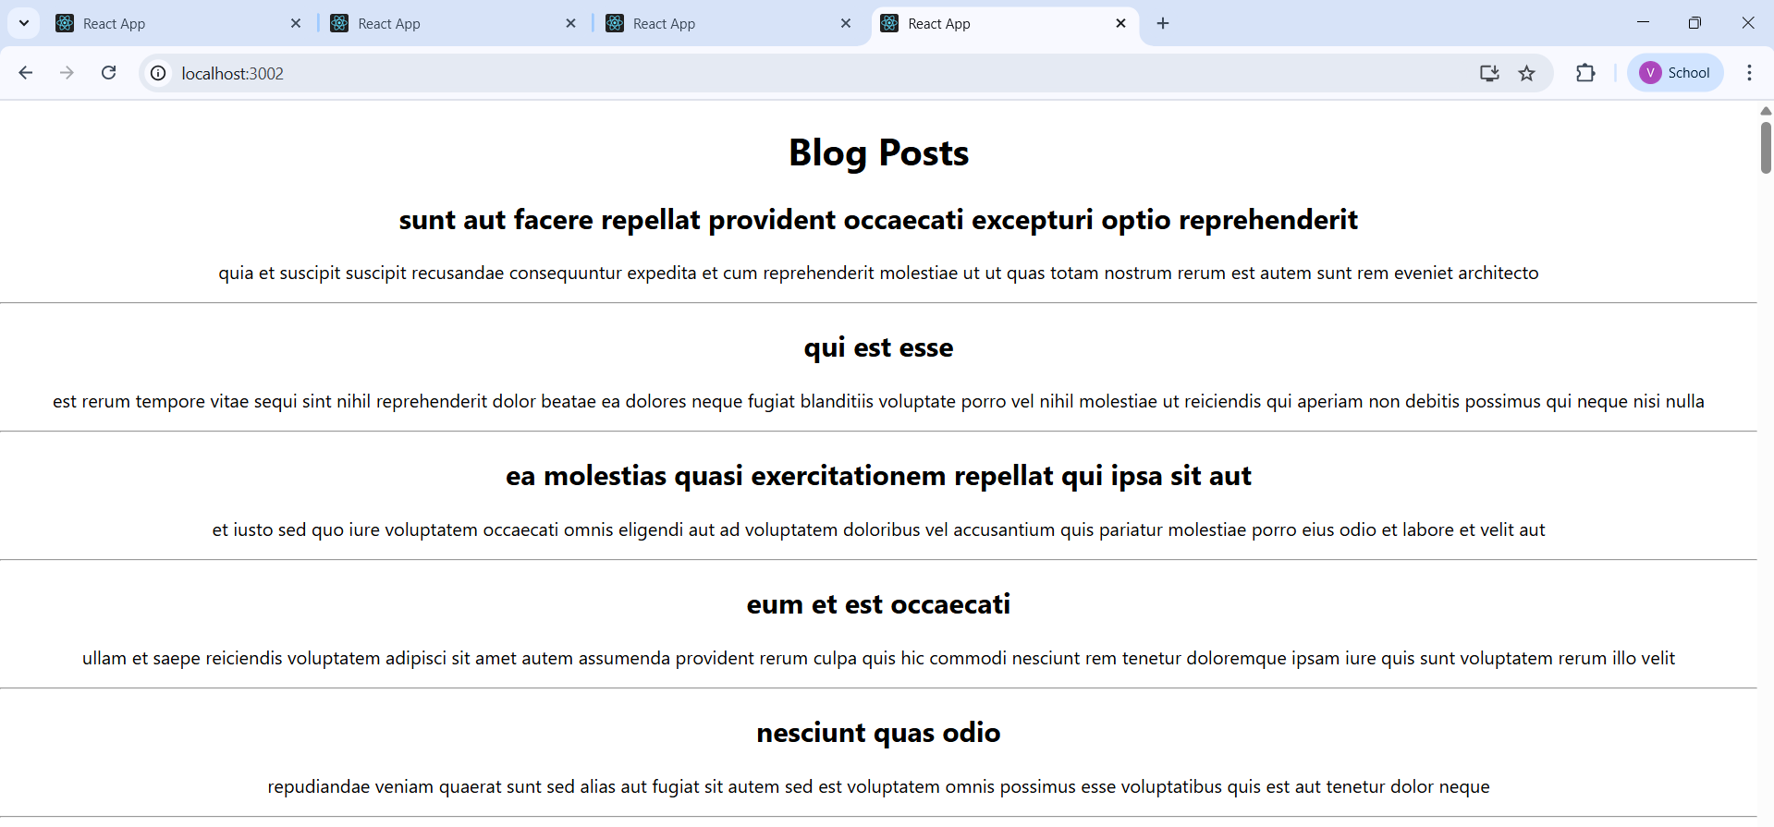

**Exercise 5: React functional component that displays information about a cohort**

**SCENARIO:**

A react application is created which displays the detail of the cohorts using react component.

**CODE:**

**CohortDetails.js**:

import React from 'react';

import styles from './CohortDetails.module.css';

function CohortDetails({ name, startDate, endDate, status }) {

const isCompleted = status === 'completed';

const statusClass = isCompleted ? styles['status-completed'] : styles['status-ongoing'];

const statusIcon = isCompleted ? '✅' : '🔵';

return (

<div className={styles.box}>

<h3 className={styles.title}>{name}</h3>

<p className={styles.paragraph}>

This cohort started on <strong>{startDate}</strong> and ended on <strong>{endDate}</strong>.<br />

The current status is: <span className={statusClass}>{statusIcon} {status}</span>

</p>

</div>

);

}

export default CohortDetails;

**CohortDetails.module.css:**

.box {

width: 320px;

margin: 20px auto;

padding: 20px;

border: 1px solid #ddd;

border-radius: 12px;

box-shadow: 0 4px 12px rgba(0, 0, 0, 0.1);

background-color: #ffffff;

text-align: center;

font-family: 'Segoe UI', Tahoma, Geneva, Verdana, sans-serif;

transition: transform 0.2s ease-in-out;

}

.box:hover {

transform: translateY(-4px);

}

.title {

font-size: 22px;

margin-bottom: 15px;

font-weight: 600;

}

.paragraph {

font-size: 16px;

line-height: 1.6;

color: #333;

}

.status-ongoing {

color: blue;

font-weight: bold;

display: inline-flex;

align-items: center;

gap: 6px;

}

.status-completed {

color: green;

font-weight: bold;

display: inline-flex;

align-items: center;

gap: 6px;

}

**App.js:**

import React from 'react';

import './App.css';

import CohortDetails from './CohortDetails';

function App() {

  return (

    <div className="App">

      <CohortDetails

        name="ReactJS July Cohort"

        startDate="2025-07-01"

        endDate="2025-07-31"

        status="ongoing"

      />

      <CohortDetails

        name="Angular June Cohort"

        startDate="2025-06-01"

        endDate="2025-06-30"

        status="completed"

      />

    </div>

  );

}

export default App;

**OUTPUT:**

